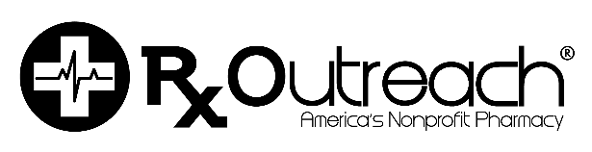

February 14, 2022

Program Updates. . .Effective immediately

New Medication

Rx Outreach Medication | Similar Medication | Available Strengths |  | Medication Cost  Quantity Fee
Lamivudine/Zidovudine tablet | Combivir® | 150/300mg |  | $55 for up to 60 tablets

Medication with Price Change

Rx Outreach Medication |  | Similar Medication | Available Strengths |  | Medication Cost  Quantity Fee
Rufinamide tablet | Banzel ® |  | 200mg |  | $75 for up to 30 tablets  $35 for up to each additional 30 tablets
Rufinamide tablet | Banzel ® |  | 400mg |  | $110 for up to 30 tablets  $70 for up to each additional 30 tablets

To see our complete list of medications available, please visit our website www.rxoutreach.org.

Our customer service center can also answer any questions or provide any additional information you may need. Contact us at 1-888-796-1234, Monday through Thursday 7:00 a.m. to 8:00 p.m. Central Time. Friday 7:00 a.m. to 5:30 p.m. Saturday 9:00 a.m. – 2:00 p.m.

